the original
FAKE NEWS

the original
Virtual Reality Games

Sec 101: Ancient Theories

the way forward

Empower
WOMEN

REFORMATION NOW!

“4 Year War”
2017-2021

ENLIST NOW!!
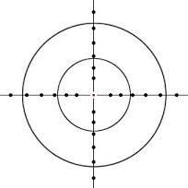

Fake News Alternate Facts
Xenophobia Jingoism
Sexism Racism
Global Warming

For Truth,
For Justice,
For America.

