The Middle
Jimmy Eat World

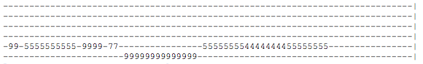

Vrs 1
D A
Hey, don't write yourself off yet.
G A D
It's only in your head you feel left out or looked down on.
D A
Just try your best, try everything you can.
G A D
And don't you worry what they tell themselves when you're away.

CHORUS
D
It just, takes some time, little girl you're in the middle
A
of the ride everything, Everything will
G D
be just fine, everything, everything will be all right (all right)

Vrs 2
D A
Hey, you know they're all the same.
G A D
You know you're doing better on your own, so don't buy in.
D A
Live right now. Yeah, just be yourself.
G A D
It doesn't matter if it's good enough for someone else.

CHORUS

The Middle
Jimmy Eat World

Vrs 3

D A
Hey, don't write yourself off yet.
G A D
It's only in your head you feel left out or looked down on.
D A
Just do your best, do everything you can.
G A D
And don't you worry what the bitter hearts are gonna say.

CHORUS
D
It just, takes some time, little girl you're in the middle
A
of the ride everything, Everything will
G D
be just fine, everything, everything will be all right (all right)

CHORUS
D

